**KEEP ON ROLLIN’ GAME DESIGN DOCUMENT**



***‘Ball Is Life’*** – Huy Tran

This page: Table of Contents and Team Member Listing

|  |  |  |
| --- | --- | --- |
| Table of Contents  [1 Game Overview](https://n-xovwktmtjsnaxyc2mwes2xu7pohqedmdm6zjw5q-2lu-script.googleusercontent.com/userCodeAppPanel)  [2 High Concept](https://n-xovwktmtjsnaxyc2mwes2xu7pohqedmdm6zjw5q-2lu-script.googleusercontent.com/userCodeAppPanel)  [3 Unique Selling Points](https://n-xovwktmtjsnaxyc2mwes2xu7pohqedmdm6zjw5q-2lu-script.googleusercontent.com/userCodeAppPanel)  [4 Platform Minimum Requirements](https://n-xovwktmtjsnaxyc2mwes2xu7pohqedmdm6zjw5q-2lu-script.googleusercontent.com/userCodeAppPanel)  [5 Competitors / Similar Titles](https://n-xovwktmtjsnaxyc2mwes2xu7pohqedmdm6zjw5q-2lu-script.googleusercontent.com/userCodeAppPanel)  [6 Synopsis](https://n-xovwktmtjsnaxyc2mwes2xu7pohqedmdm6zjw5q-2lu-script.googleusercontent.com/userCodeAppPanel)  [7 Game Objectives](https://n-xovwktmtjsnaxyc2mwes2xu7pohqedmdm6zjw5q-2lu-script.googleusercontent.com/userCodeAppPanel)  [8 Game Rules](https://n-xovwktmtjsnaxyc2mwes2xu7pohqedmdm6zjw5q-2lu-script.googleusercontent.com/userCodeAppPanel)  [9 Game Structure](https://n-xovwktmtjsnaxyc2mwes2xu7pohqedmdm6zjw5q-2lu-script.googleusercontent.com/userCodeAppPanel)  [10 Game Play](https://n-xovwktmtjsnaxyc2mwes2xu7pohqedmdm6zjw5q-2lu-script.googleusercontent.com/userCodeAppPanel)  [10.1 Game Controls](https://n-xovwktmtjsnaxyc2mwes2xu7pohqedmdm6zjw5q-2lu-script.googleusercontent.com/userCodeAppPanel)  [10.2 Game Camera](https://n-xovwktmtjsnaxyc2mwes2xu7pohqedmdm6zjw5q-2lu-script.googleusercontent.com/userCodeAppPanel)  [10.2.1 HUD](https://n-xovwktmtjsnaxyc2mwes2xu7pohqedmdm6zjw5q-2lu-script.googleusercontent.com/userCodeAppPanel)  [10.2.2 Maps](https://n-xovwktmtjsnaxyc2mwes2xu7pohqedmdm6zjw5q-2lu-script.googleusercontent.com/userCodeAppPanel)  [11 Players](https://n-xovwktmtjsnaxyc2mwes2xu7pohqedmdm6zjw5q-2lu-script.googleusercontent.com/userCodeAppPanel)  [11.1 Characters](https://n-xovwktmtjsnaxyc2mwes2xu7pohqedmdm6zjw5q-2lu-script.googleusercontent.com/userCodeAppPanel)  [11.2 Metrics](https://n-xovwktmtjsnaxyc2mwes2xu7pohqedmdm6zjw5q-2lu-script.googleusercontent.com/userCodeAppPanel)  [11.3 States](https://n-xovwktmtjsnaxyc2mwes2xu7pohqedmdm6zjw5q-2lu-script.googleusercontent.com/userCodeAppPanel)  [11.4 Weapons](https://n-xovwktmtjsnaxyc2mwes2xu7pohqedmdm6zjw5q-2lu-script.googleusercontent.com/userCodeAppPanel)  [12 Player Line-up](https://n-xovwktmtjsnaxyc2mwes2xu7pohqedmdm6zjw5q-2lu-script.googleusercontent.com/userCodeAppPanel)  [13 NPC](https://n-xovwktmtjsnaxyc2mwes2xu7pohqedmdm6zjw5q-2lu-script.googleusercontent.com/userCodeAppPanel)  [13.1 Enemies](https://n-xovwktmtjsnaxyc2mwes2xu7pohqedmdm6zjw5q-2lu-script.googleusercontent.com/userCodeAppPanel)  [13.1.1 Enemy States](https://n-xovwktmtjsnaxyc2mwes2xu7pohqedmdm6zjw5q-2lu-script.googleusercontent.com/userCodeAppPanel)  [13.1.2 Enemy Spawn Points](https://n-xovwktmtjsnaxyc2mwes2xu7pohqedmdm6zjw5q-2lu-script.googleusercontent.com/userCodeAppPanel)  [13.2 Allies / Companions](https://n-xovwktmtjsnaxyc2mwes2xu7pohqedmdm6zjw5q-2lu-script.googleusercontent.com/userCodeAppPanel)  [13.2.1 Ally States](https://n-xovwktmtjsnaxyc2mwes2xu7pohqedmdm6zjw5q-2lu-script.googleusercontent.com/userCodeAppPanel)  [13.2.2 Ally Spawn Points](https://n-xovwktmtjsnaxyc2mwes2xu7pohqedmdm6zjw5q-2lu-script.googleusercontent.com/userCodeAppPanel)  [14 Art](https://n-xovwktmtjsnaxyc2mwes2xu7pohqedmdm6zjw5q-2lu-script.googleusercontent.com/userCodeAppPanel)  [14.1 Setting](https://n-xovwktmtjsnaxyc2mwes2xu7pohqedmdm6zjw5q-2lu-script.googleusercontent.com/userCodeAppPanel)  [14.2 Level Design](https://n-xovwktmtjsnaxyc2mwes2xu7pohqedmdm6zjw5q-2lu-script.googleusercontent.com/userCodeAppPanel)  [14.3 Audio](https://n-xovwktmtjsnaxyc2mwes2xu7pohqedmdm6zjw5q-2lu-script.googleusercontent.com/userCodeAppPanel)  [15 Procedurally Generated Content](https://n-xovwktmtjsnaxyc2mwes2xu7pohqedmdm6zjw5q-2lu-script.googleusercontent.com/userCodeAppPanel)  [15.1 Environment](https://n-xovwktmtjsnaxyc2mwes2xu7pohqedmdm6zjw5q-2lu-script.googleusercontent.com/userCodeAppPanel)  [15.2 Levels](https://n-xovwktmtjsnaxyc2mwes2xu7pohqedmdm6zjw5q-2lu-script.googleusercontent.com/userCodeAppPanel)  [15.3 Artificial Intelligence NPC](https://n-xovwktmtjsnaxyc2mwes2xu7pohqedmdm6zjw5q-2lu-script.googleusercontent.com/userCodeAppPanel)  [15.4 Visual Arts](https://n-xovwktmtjsnaxyc2mwes2xu7pohqedmdm6zjw5q-2lu-script.googleusercontent.com/userCodeAppPanel)  [15.5 Audio](https://n-xovwktmtjsnaxyc2mwes2xu7pohqedmdm6zjw5q-2lu-script.googleusercontent.com/userCodeAppPanel)  [15.6 Minimum Viable Product (MVP)](https://n-xovwktmtjsnaxyc2mwes2xu7pohqedmdm6zjw5q-2lu-script.googleusercontent.com/userCodeAppPanel)  [16 Wish List](https://n-xovwktmtjsnaxyc2mwes2xu7pohqedmdm6zjw5q-2lu-script.googleusercontent.com/userCodeAppPanel)   |  | | --- | |  | | Game Development Team Members    PRODUCER  Huy Tran    PRODUCTION MANAGER  Huy Tran    PRODUCTION COORDINATOR  Huy Tran  GAME DESIGNERS  Huy Tran  SYSTEMS/IT COORDINATOR  Huy Tran  PROGRAMMERS  Huy Tran  TECHNICAL ARTISTS  Huy Tran  AUDIO ENGINEERS  Huy Tran  UX TESTERS  Huy Tran |

|  |
| --- |
|  |

# 1 Game Overview

Title: Keep On Rollin’

Platform: PC Standalone

Genre: 3D Platformer

Rating: (10+) ESRB

Target: Casual gamer (aging from 12 - 30)

Release date: May, 2020

Publisher: Huy Tran

Keep On Rollin’ is a 3D platformer where the Player is a ball that can roll around the track floating above the sea. The player must collect all the Gems on the track within the time limit. There is an achievement system where the Player can find and collect up to 3 Stars in the map to make the game more challenging.

# 2 High Concept

Keep On Rollin’ sets the Player on a track that floats above the sea where the Player can roll around the track freely. The Player has to collect all the Gems on th

The Player may step on the Speed boost platforms to get a boost in speed to help get to places that the Player cannot do with normal speed.

# 3 Unique Selling Points

* Compatible with Windows and Mac OS X
* Unique and minimalist artwork
* Simple yet engaging gameplay
* Players can compete with each other

# 4 Platform Minimum Requirements

PC, MAC STANDALONE

OS: Windows XP SP2+, Mac OS X 10.0+

Graphics card: DX9 (shader model 2.0) capabilities; generally everything made since 2004 should work

# 5 Competitors / Similar Titles

Super Monkey Ball by Sega

Roll-a-ball by Unity Technologies

# 6 Synopsis

# 7 Game Objectives

The objective is to collect all the gems within the time limit. The player can also collect up to 3 stars in each level for an additional achievement but it is not necessary.

# 8 Game Rules

# 9 Game Structure

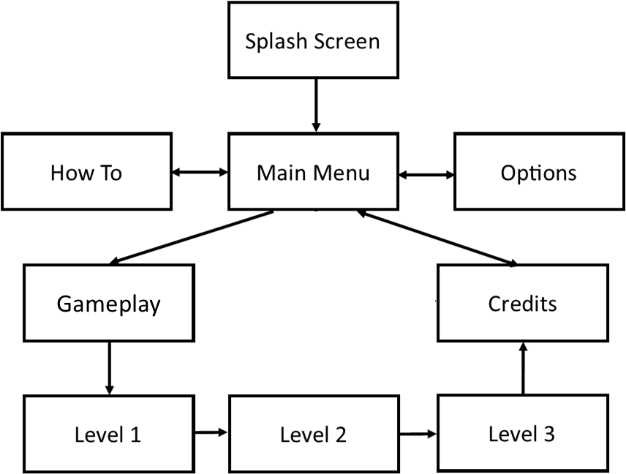

# 10 Game Play

## 10.1 Game Controls (PC)

**MOVE PAUSE**

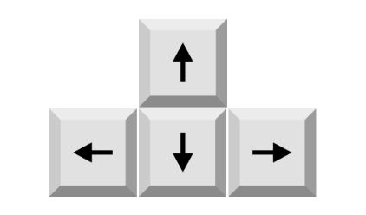

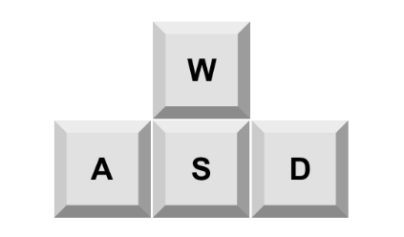



**or**

**or**

## 10.2 Game Camera

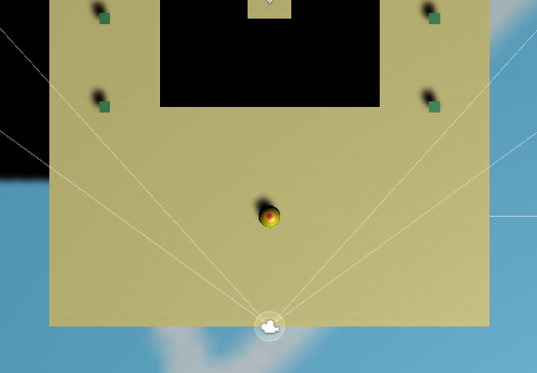

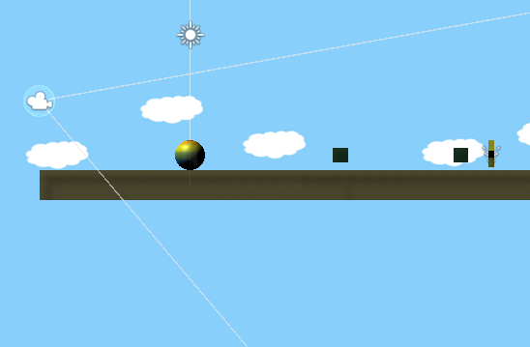

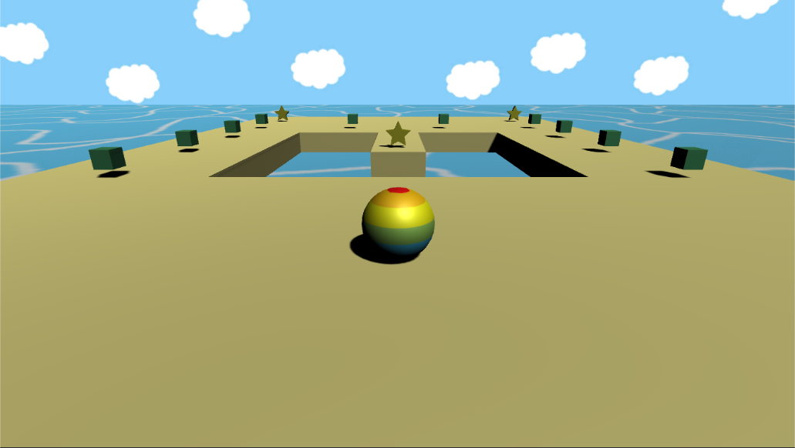

### 10.2.1 HUD

### 

### 10.2.2 Maps

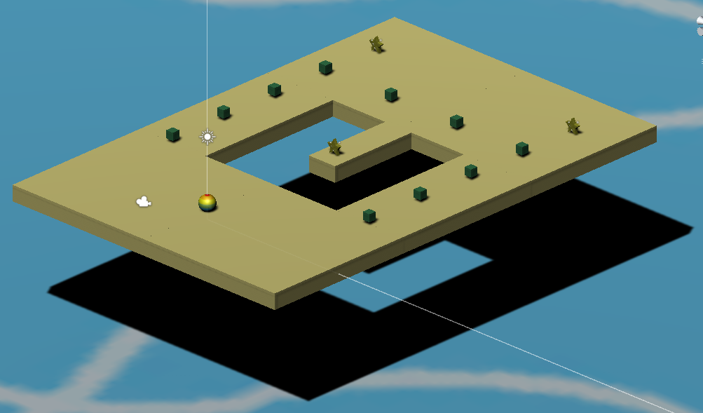

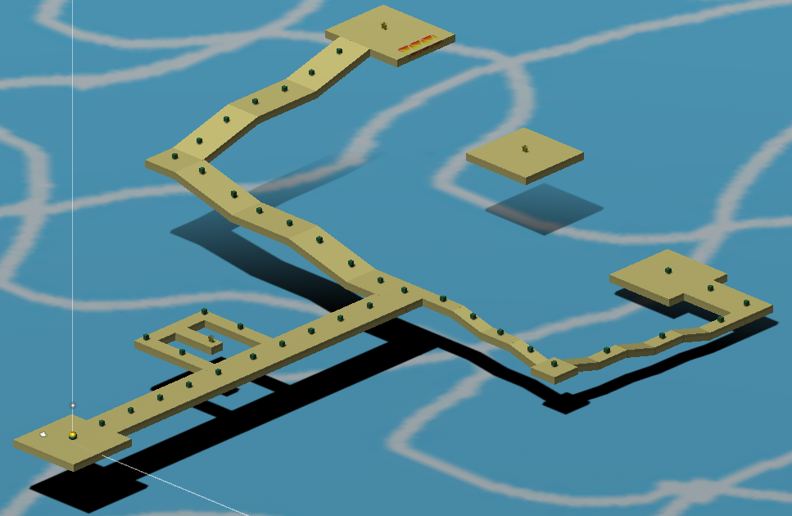

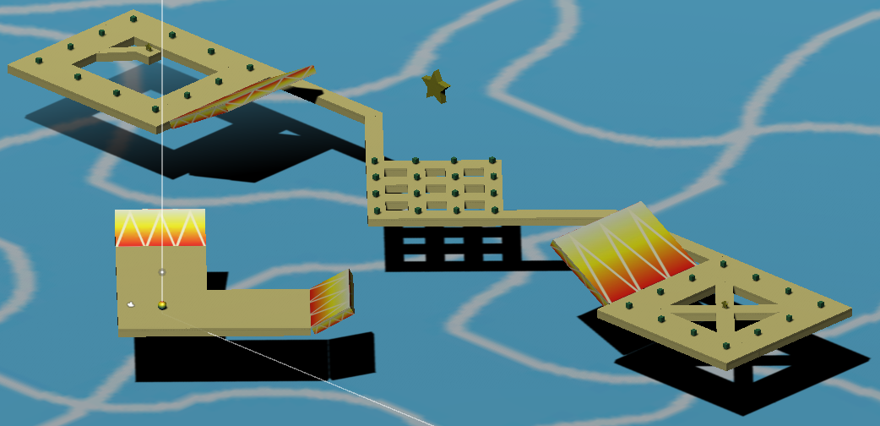

# 11 Players

## 11.1 Characters

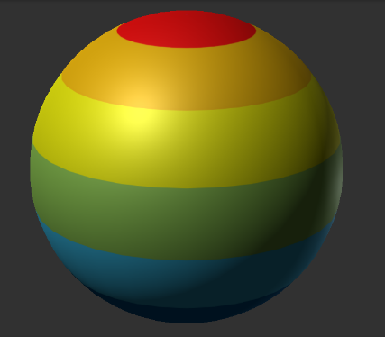

## 11.2 Metrics

Diameter: 1 m

Speed: 1000

## 11.3 States

The Player animation is static. All states of the Player including Idle, Move, Death will have the same static animation. When the Player stands on the cloud, they will move along with the cloud

## 11.4 Weapons

N/A

# 12 Player Line-up

N/A

# 13 NPC

## 13.1 Enemies

N/A

### 13.1.1 Enemy States

N/A

### 13.1.2 Enemy Spawn Points

N/A

## 13.2 Allies / Companions

N/A

### 13.2.1 Ally States

N/A

### 13.2.2 Ally Spawn Points

N/A

# 14 Art

## 14.1 Setting

The game takes place outside, in an open landscape where you can see grass, mountains, the sun and the sky. The sky with clouds are the only things in the background when the Player goes up until they reaches the house in normal mode.

## 14.2 Level Design

Clouds will spawn at random size and their speed will increase gradually the higher the Player goes.

## 14.3 Audio

|  |  |  |
| --- | --- | --- |
| NAME | CATEGORY | DESCRIPTION |
| Beach Town Guitar Theme | Background music | Plays and loops throughout the game |
| Gem | FX | When the player collect a gem |
| Lose | FX | When the timer runs out |
| Star | FX | When the player collect a star |
| Start Countdown (3, 2, 1, Go!) | FX | Start countdown at the beginning of scene |
| Water Splash | FX | When the player falls into the sea |
| Win | FX | When the player collects all the gem |

# 15 Procedurally Generated Content

## 15.1 Environment

N/A

## 15.2 Levels

N/A

## 15.3 Artificial Intelligence NPC

N/A

## 15.4 Visual Arts

N/A

## 15.5 Audio

N/A

## 15.6 Minimum Viable Product (MVP)

* Built for the PC platform (Windows and Mac OS X)
* Collectible Gems and Stars
* Lose when timer runs out
* Platforms to move on
* Speed boost platform to boost the player’s speed
* Player respawns at the original position when fall into the sea
* One Player character
* Background music that plays and loops throughout the game
* Have a star achievement system

# 16 Wish List

* Fix the ball’s physics
  + Sometimes the ball jumps up randomly
* Add animation to the sea and water splash
* Add more ball designs for the player to choose from
* Add more levels
* Add other obstacle that could affect the difficulty of the game